

WEEK | Week 12: Web Application Security Testing with DVWA and Mutillidae
Name | Muhammad Haseeb
Registration No | C11/26/FCDF/17
GUIDED LAB WINDOW | 29-30 August 2026
SELF-PACED WINDOW | Monday–Friday after the guided session
SUBMISSION DEADLINE | 6-September,2026, 23:59 WAT
LMS ITEMS | Lab 2
Linux Version | 6.18. 12+kali-amd64
Vm hostname | Kali+Metasploitable2

Lab 2: Web Application Security Testing
DVWA and Mutillidae - Burp Suite, file-upload validation, Nikto, DIRB and SQL injection - fully guided.
EVIDENCE:
DVWA-LAB Security level:
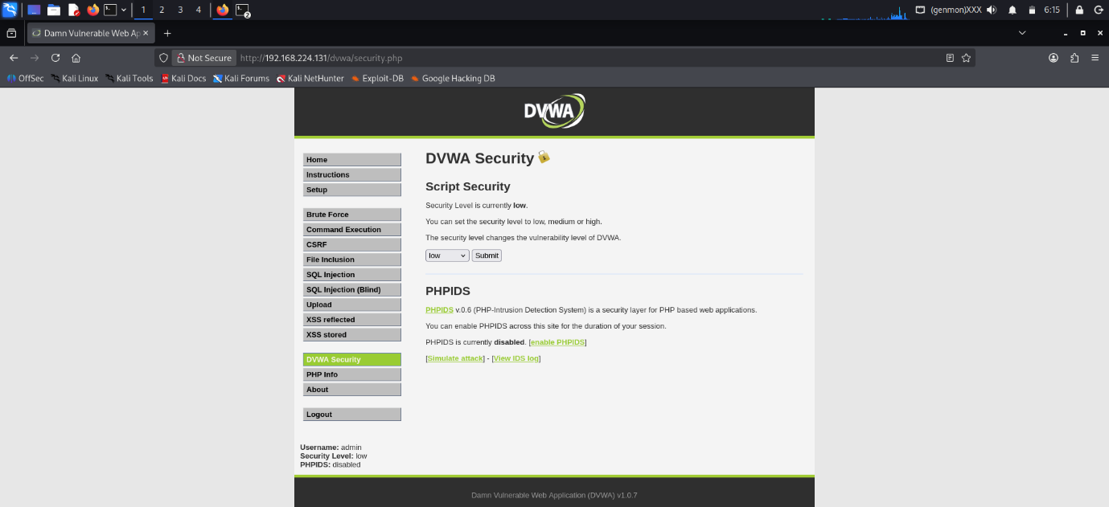
explanation:
I have opened the DVWA lab from metasploitable2 Vm and enter in it as an admin user. Initially the security Level was set to High. I have changed it to the low for starting the practise.

Browser Developers Tool:
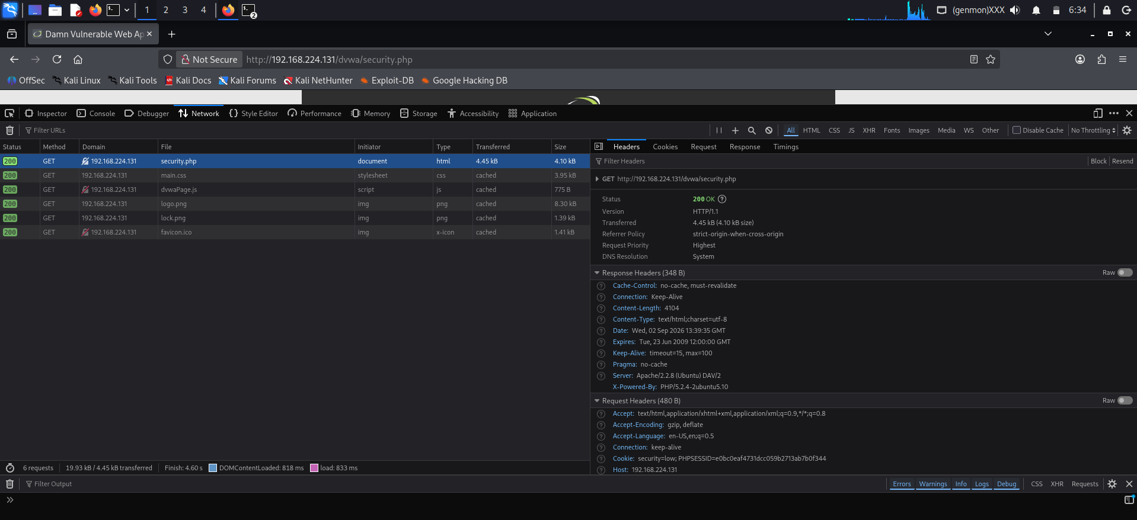
Explanation:
A normal HTTP GET request was inspected using the browser Developer Tools. The request details show the requested URL, HTTP method and server response status. Cookie values were not included in the evidence to avoid exposing session information.
Cookies:
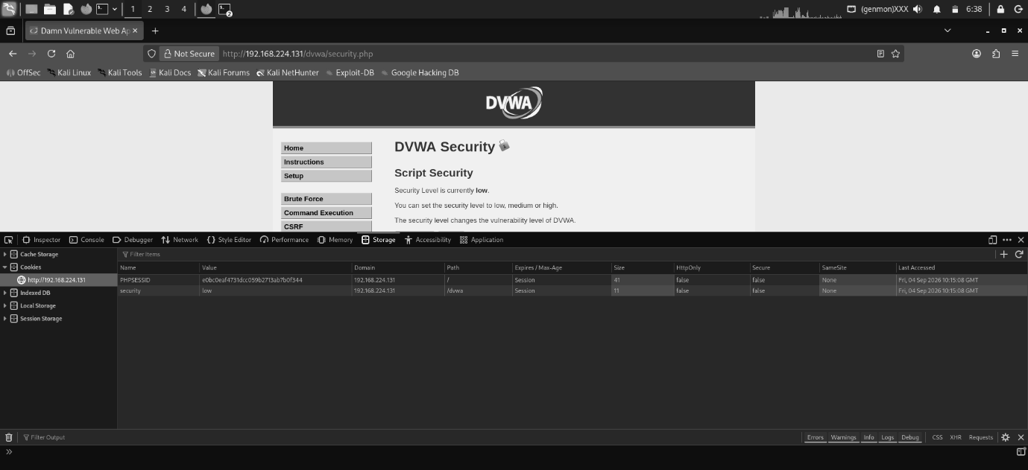
TWO cookies:
PHPSESSID AND SECURITY these are the names of those cookies.
BURP SUITE INTEGRATION:
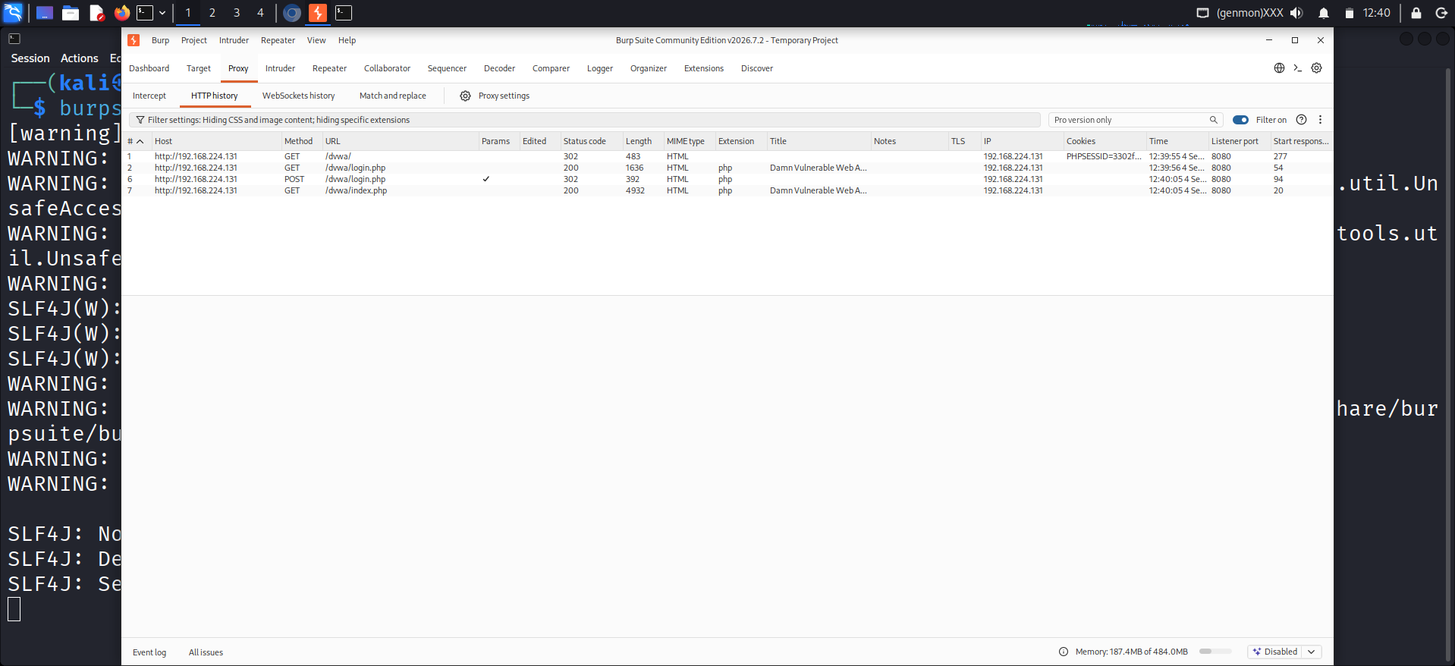
EXPLANATION:
we have started burp suite to configure requests, intercept them, modify them according to use.
INTERCEPTED DVWA INDEX PAGE REQUEST:
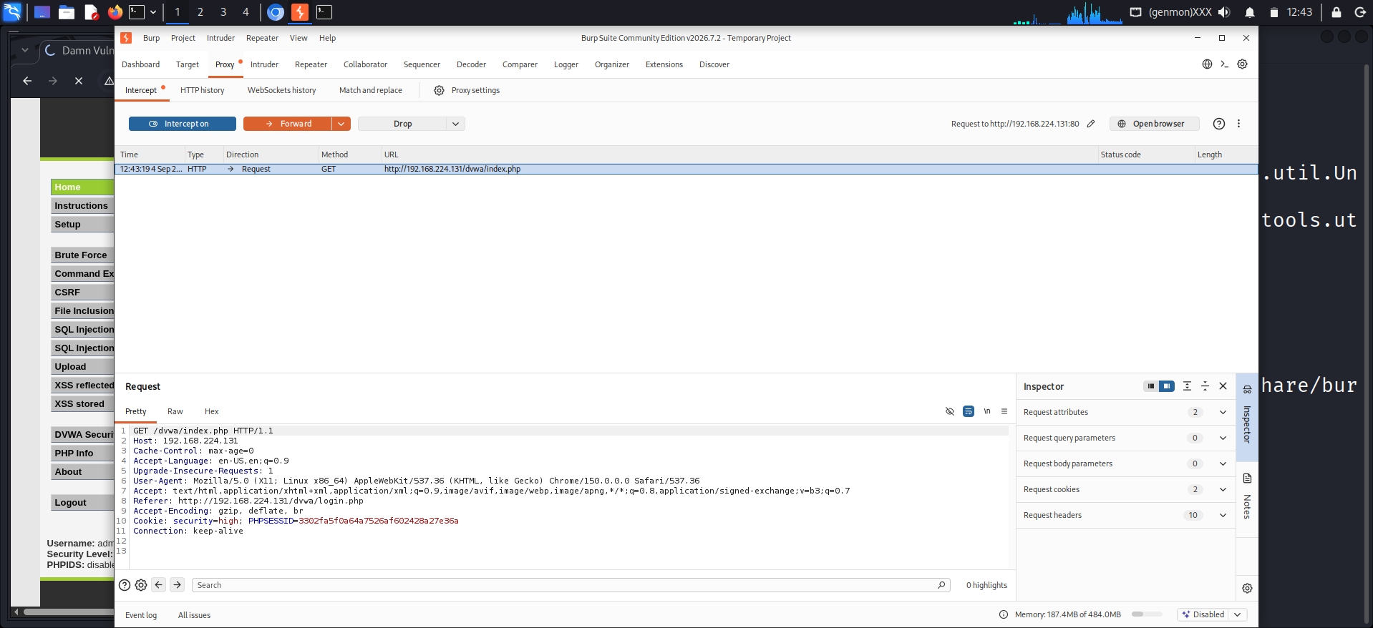
EXPLANATION:
I have intercepted the request of main insex page of DVWA and in the request their are sensitive info like cookie value.
TEST FILE FOR UPLOADING:
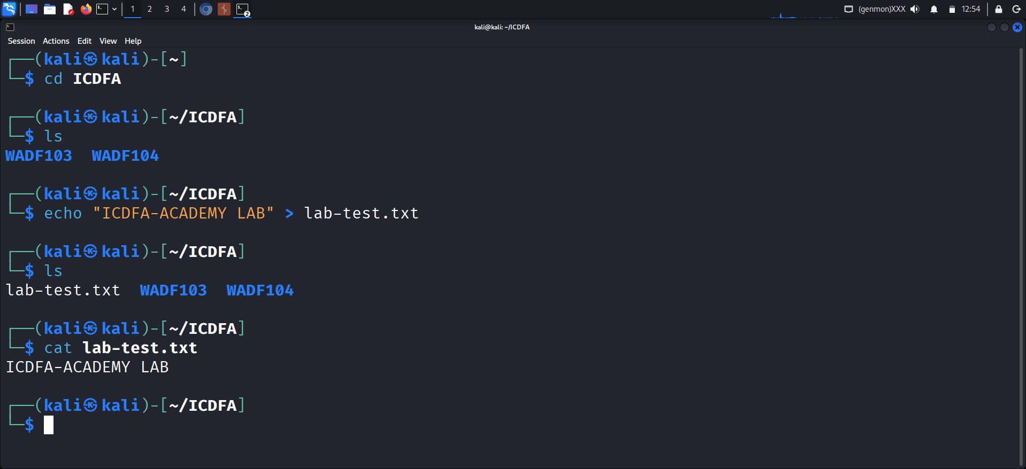
EXPLANATION:
I have just created the test file to upload in DVWA to confirm file uploading vulnerability. It is a small test file with written inside “ICDFA-ACAADEMY LAB” if it can be uploaded then we will upload a file that will create a reverse shell form it.
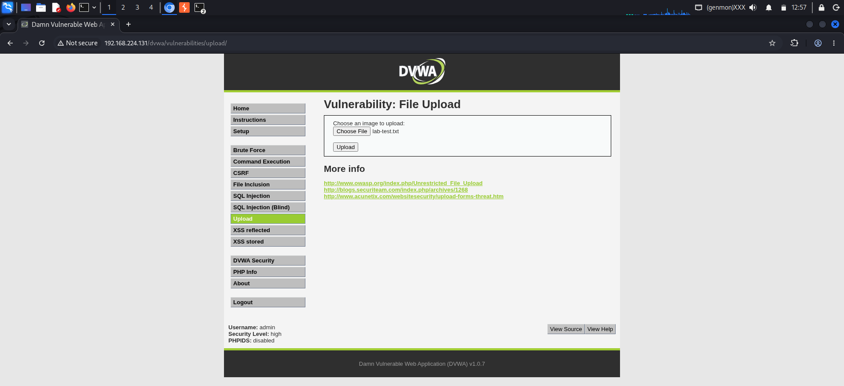
FILE HAS BEEN UPLOADED.

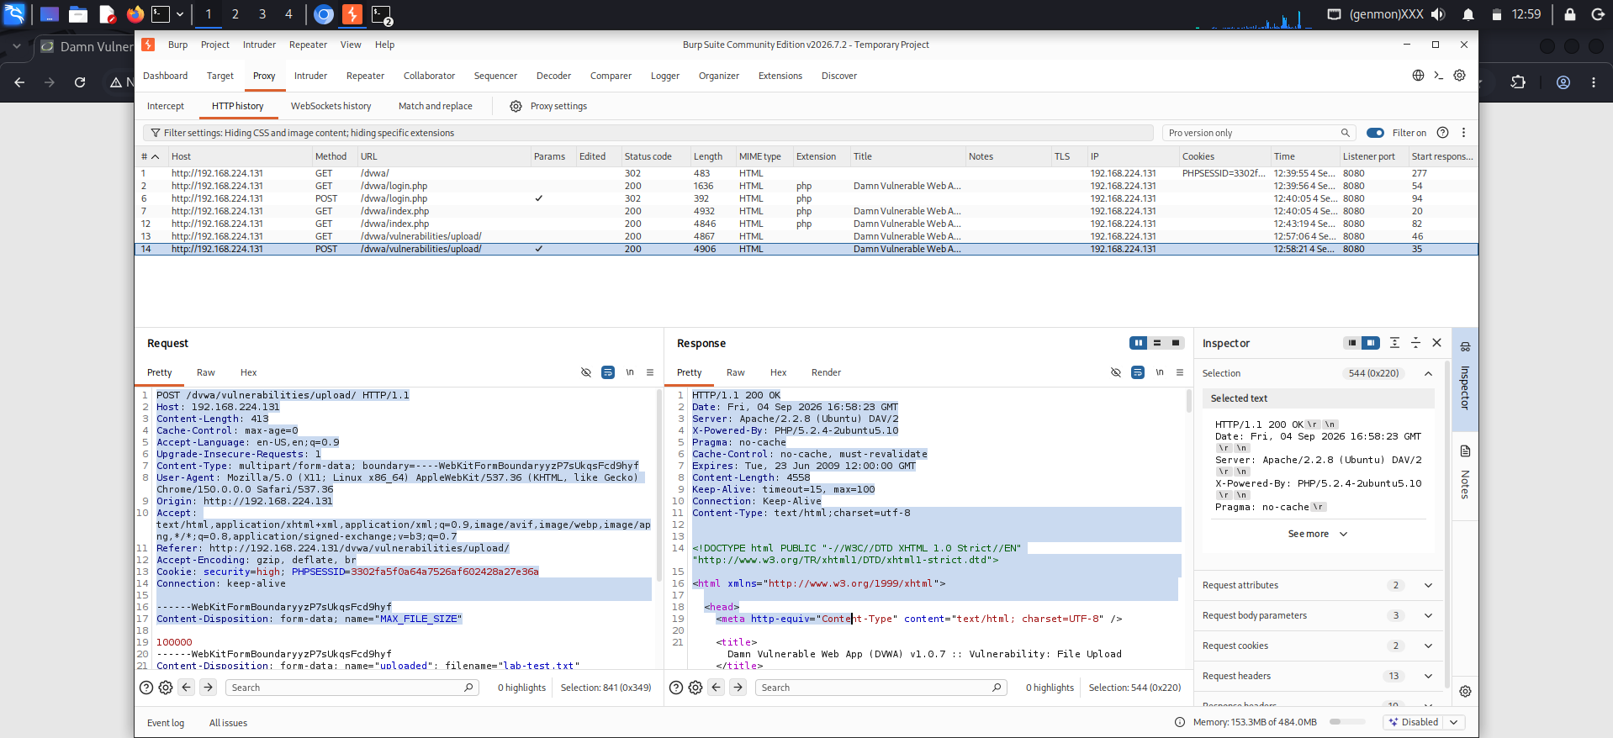
INTERCEPTED UPLOAD REQUEST:
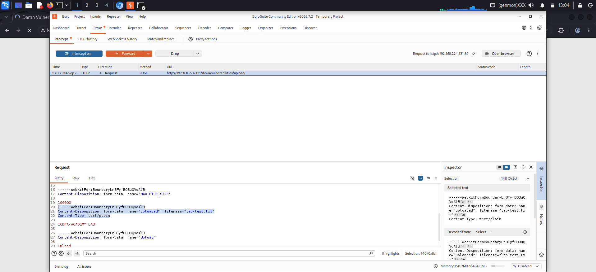
above is the intercepted post request of DVWA file upload method.
EXTENSION CHANGED FROM txt to log:
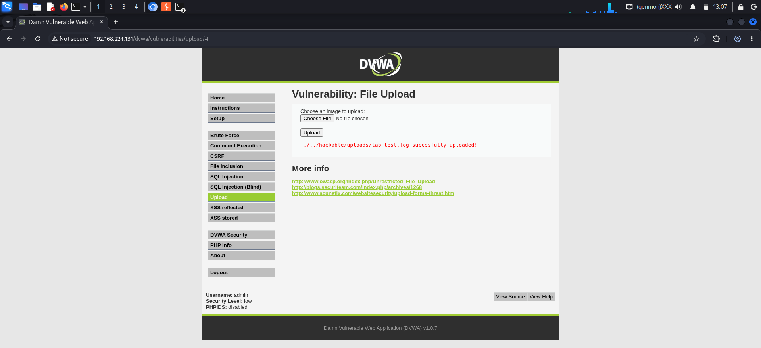
Explanation:
No effect was there as the extension changes from text to log but it was acceptable from the server. This shows file uploading vulnerability.
Tampering Intercepted request:
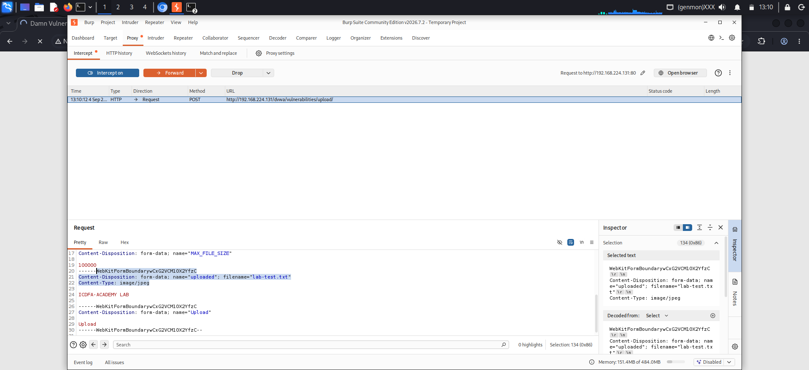
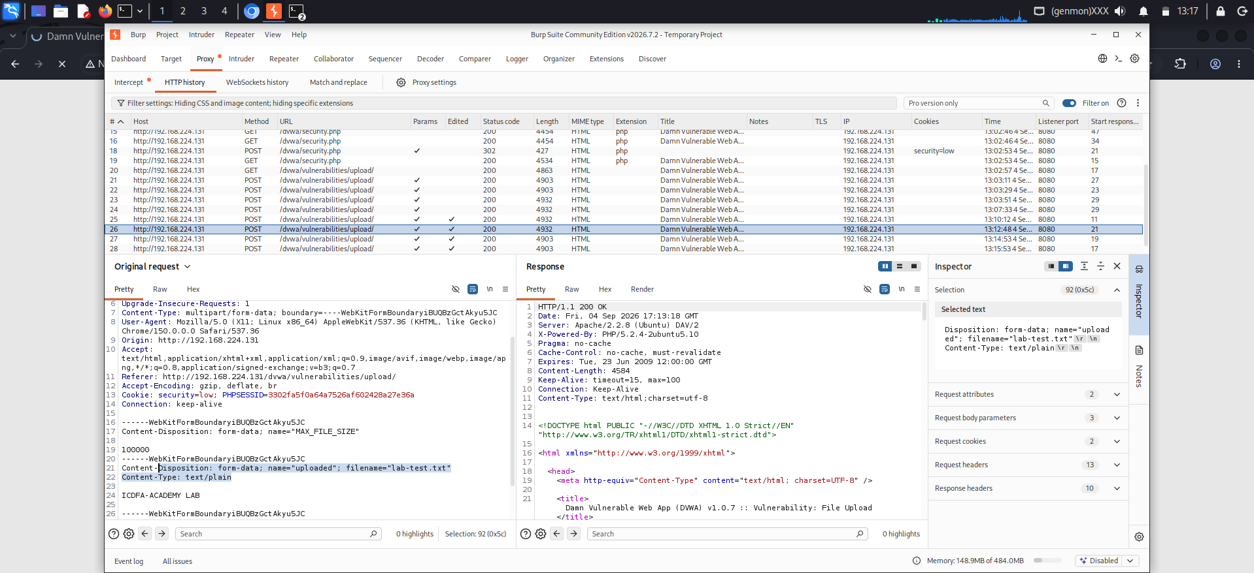
Explanation:
A harmless text file was uploaded. Burp Suite was used to intercept the upload request, and only the Content-Type header was changed from text/plain to image/jpeg. The file content itself was not modified. After forwarding the modified request, the application continued to handle the file as text/plain. No successful MIME-type bypass was observed. The test demonstrates that the client-supplied MIME type should not be considered trustworthy by itself. In this test, however, the application did not appear to accept the modified MIME type as sufficient to treat the text file as a JPEG. Therefore, no direct security impact was demonstrated.
Storage location:
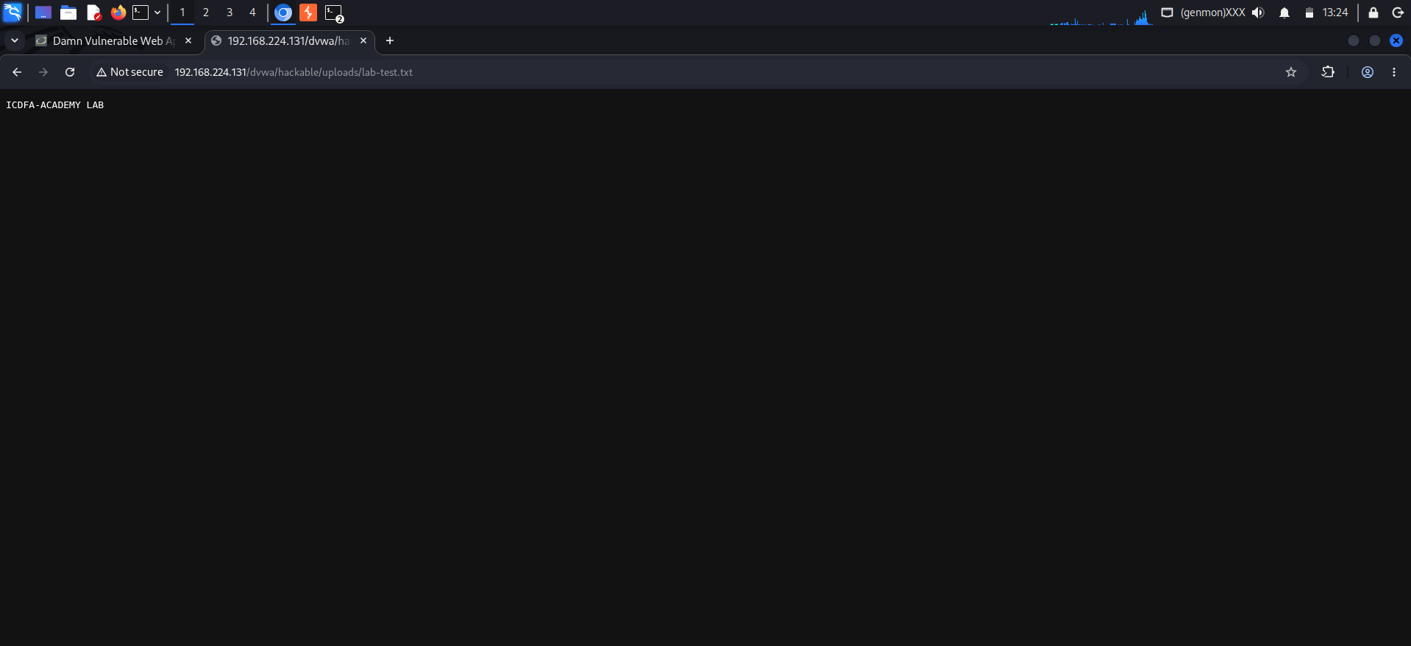
EXPLANATION:
The uploaded file was successfully accessible through the web browser using its upload path. This confirms that the upload directory is web-accessible, allowing uploaded files to be directly viewed or downloaded. A web-accessible upload directory may allow uploaded files to be accessed directly by users. If an application accepts unsafe or executable files, this could increase the risk of unauthorized file access or code execution.
Nikto (Web Server Assessment):
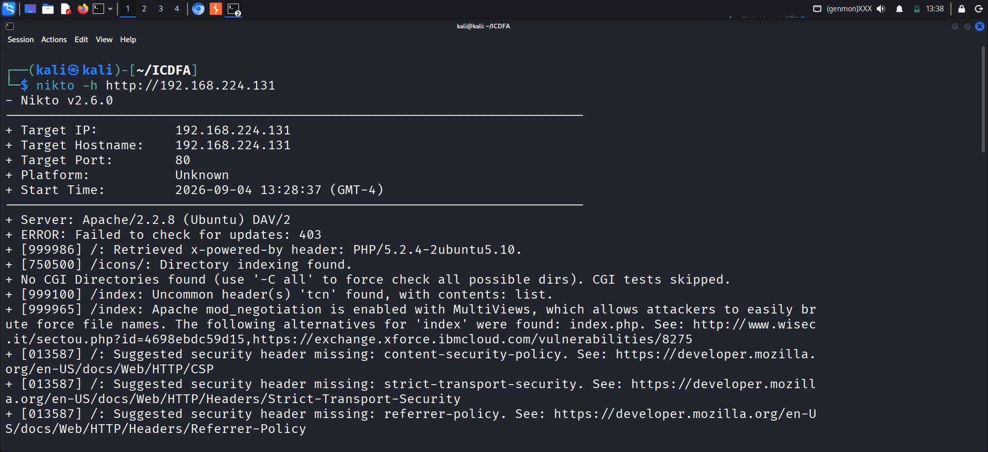
Outdated Apache Server (Version 2.2.8):
The scan detected an old Apache version that is no longer supported. Older software often contains unpatched security flaws, so the server should be upgraded to a modern, supported release.
Obsolete PHP Version (5.2.4):
The server is running a legacy PHP release that has reached end-of-life. Continuing to use unsupported software exposes the system to known vulnerabilities and potential exploits.
Directory Indexing Enabled:
Directory listing is active on sensitive paths (/icons/, /doc/, and /test/). This allows unauthorized users to view the contents of these directories, risking the exposure of internal files.
Exposed phpinfo.php File:
The /phpinfo.php script is publicly accessible, revealing detailed server and PHP configuration data. Attackers can leverage this technical insight to map out the environment for further attacks.
HTTP TRACE Method Active:
The HTTP TRACE method is enabled on the server, which can introduce Cross-Site Tracing (XST) risks. This finding should be independently validated to confirm whether it poses an active threat.
SAVED OUTPUT IN FILE:
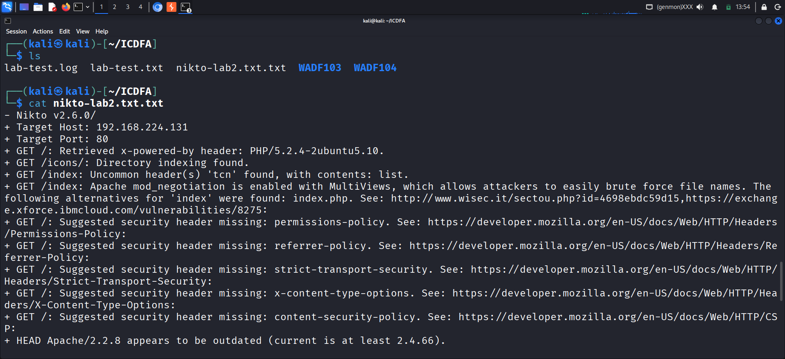
Part 8 - DIRB (Content Discovery):
Runing DIRB:
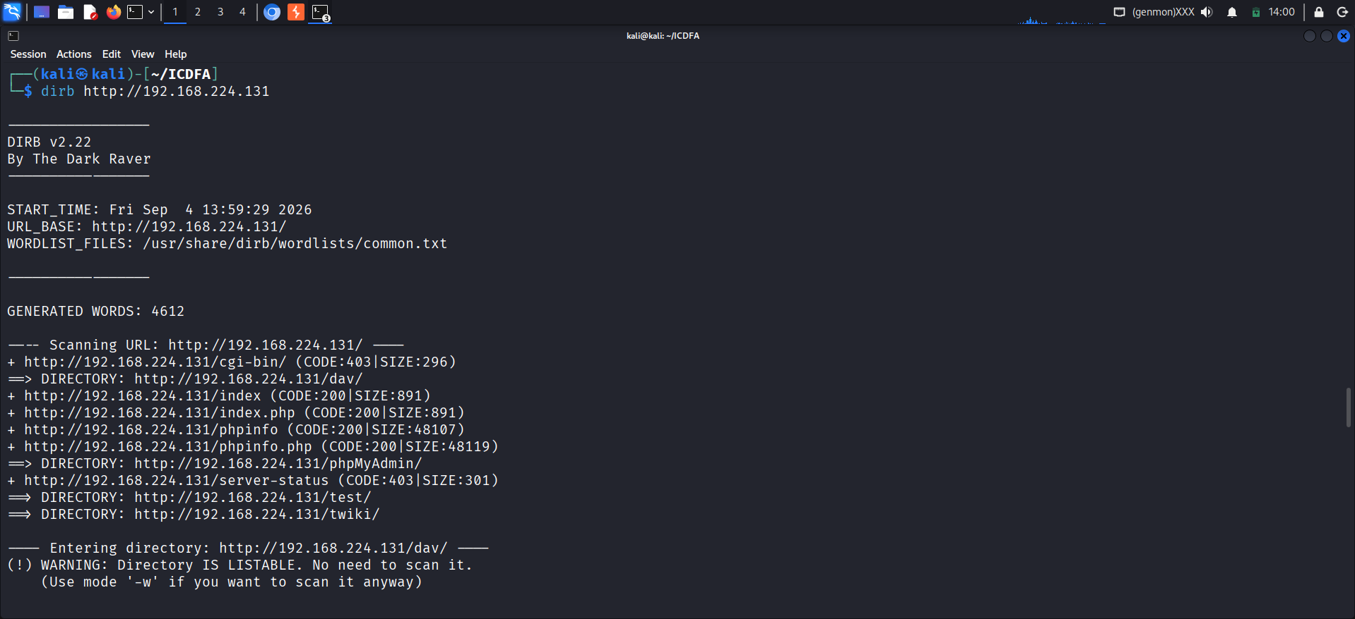
http://192.168.224.131/cgi-bin/ — 403 Forbidden
The directory exists but access is denied.
http://192.168.224.131/phpinfo.php — 200 OK
The PHP information page is accessible and may disclose detailed server configuration information.
http://192.168.224.131/phpMyAdmin/ — Directory Found
A web-based database administration interface was discovered.
http://192.168.224.131/test/ — Directory Found
The directory exists and DIRB reported that it is listable.
http://192.168.224.131/dav/ — Directory Found / Listable
The WebDAV-related directory exists and was reported as listable.
DIRB to uploads:
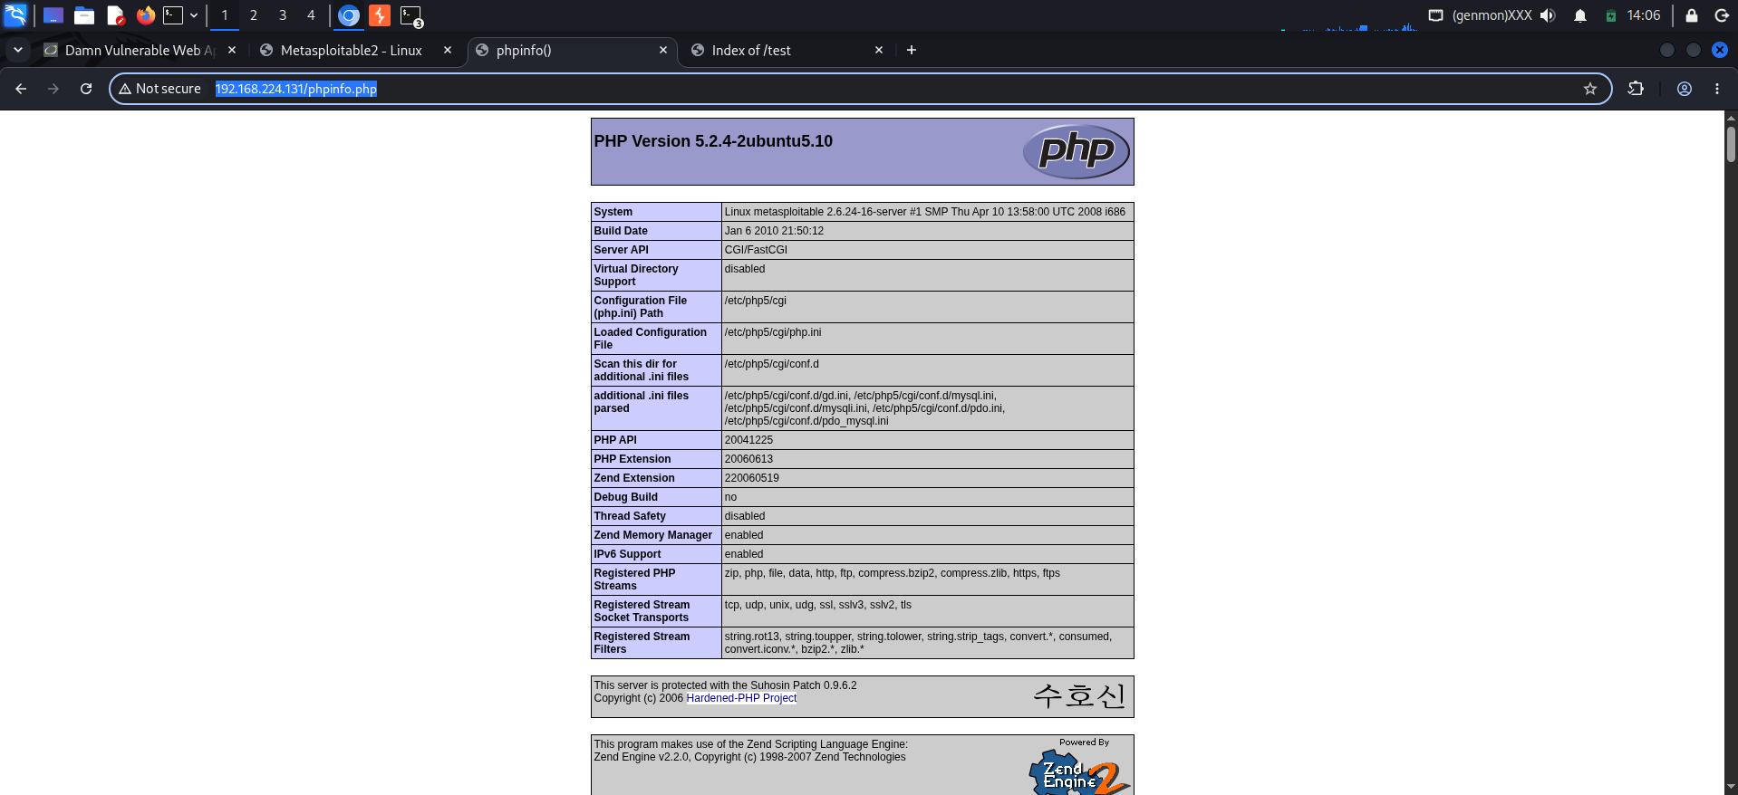
EXPLANATION:
The DIRB scan identified web-accessible directories such as /test/ and /dav/, demonstrating that predictable or unlinked directories can be discovered through path enumeration. The earlier DVWA upload test confirmed that the uploaded file was accessible through the /dvwa/hackable/uploads/ path. This supports the observation that upload storage can become web-accessible when it is located under a publicly served web directory.
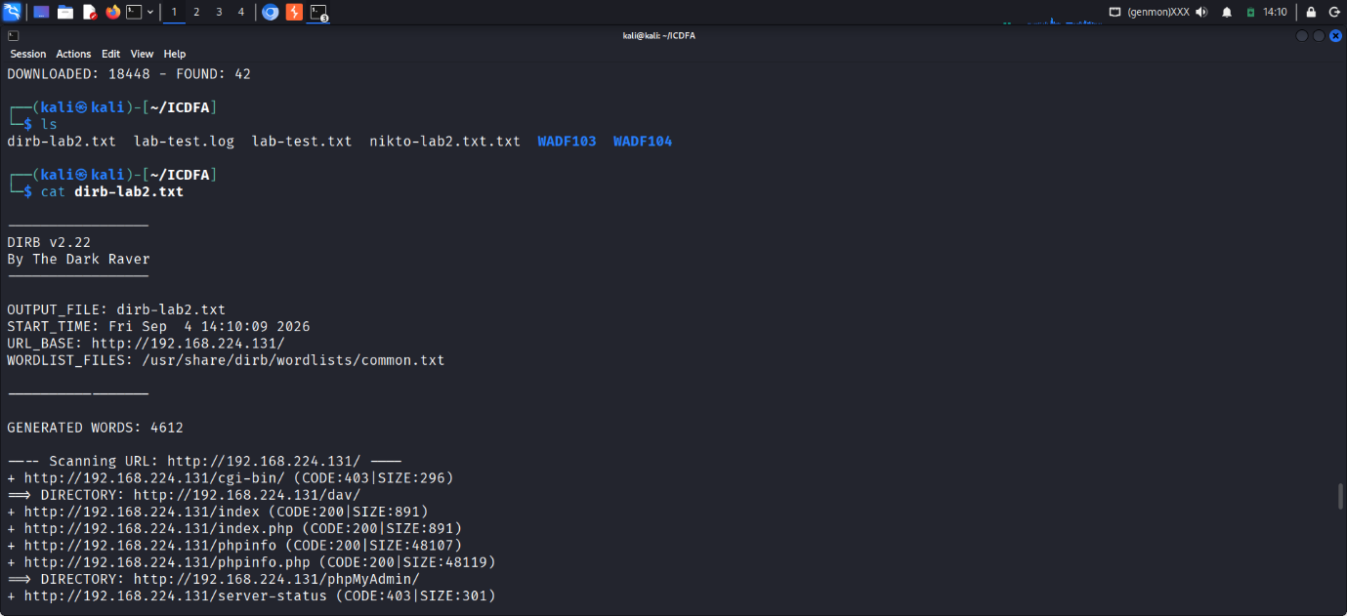
EXPLANATION:
Outputs was successfully saved in the file.
Mutillidae Input Mapping:
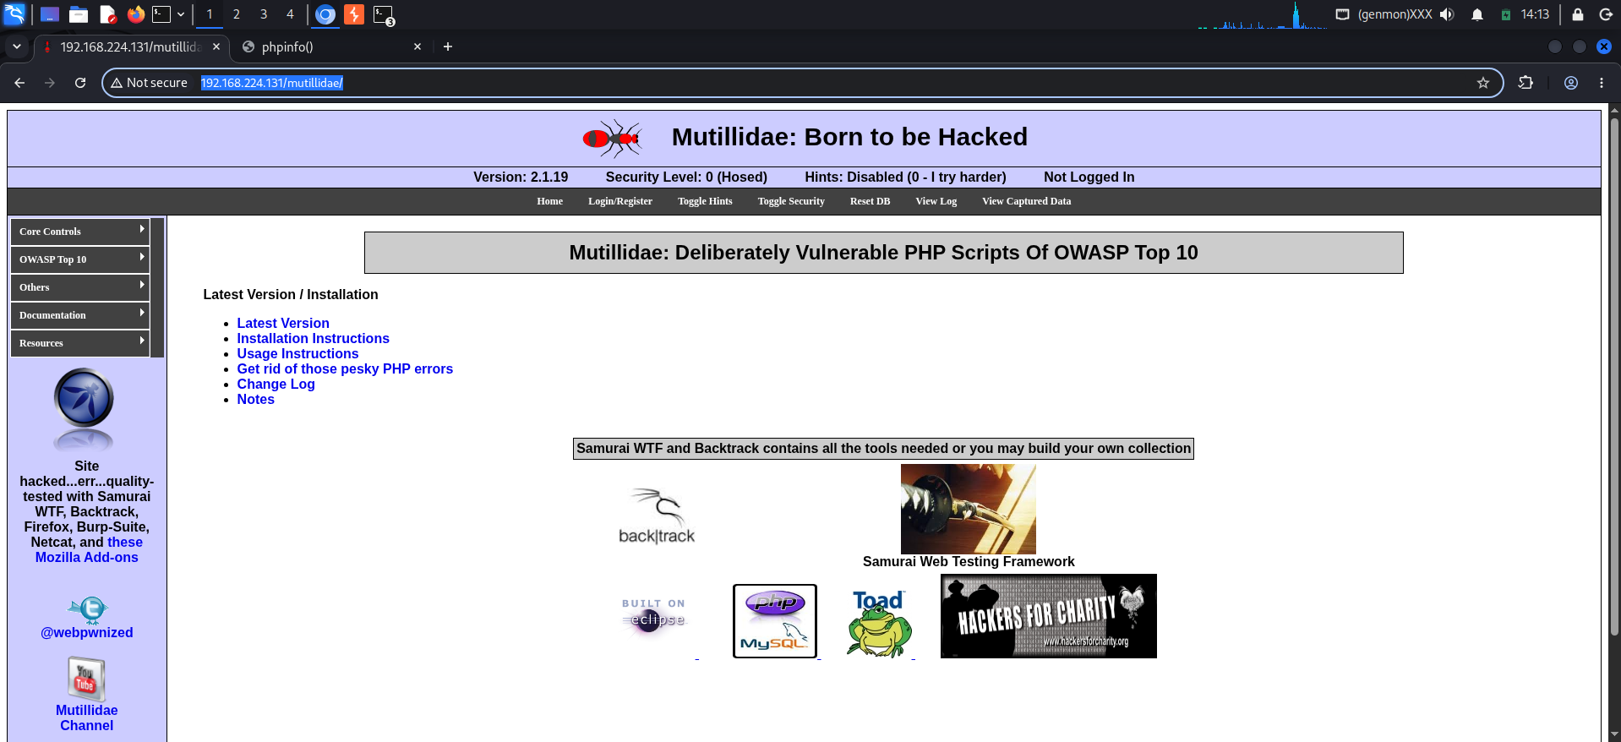
MAPPING INPUT PARAMETERS:
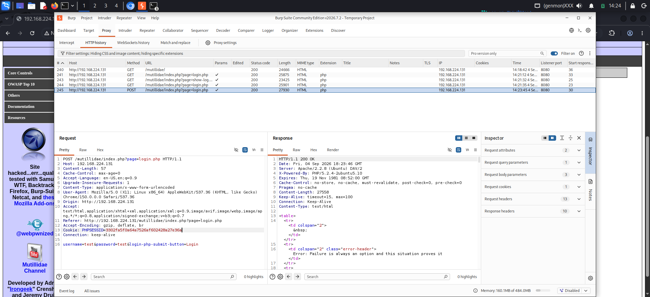
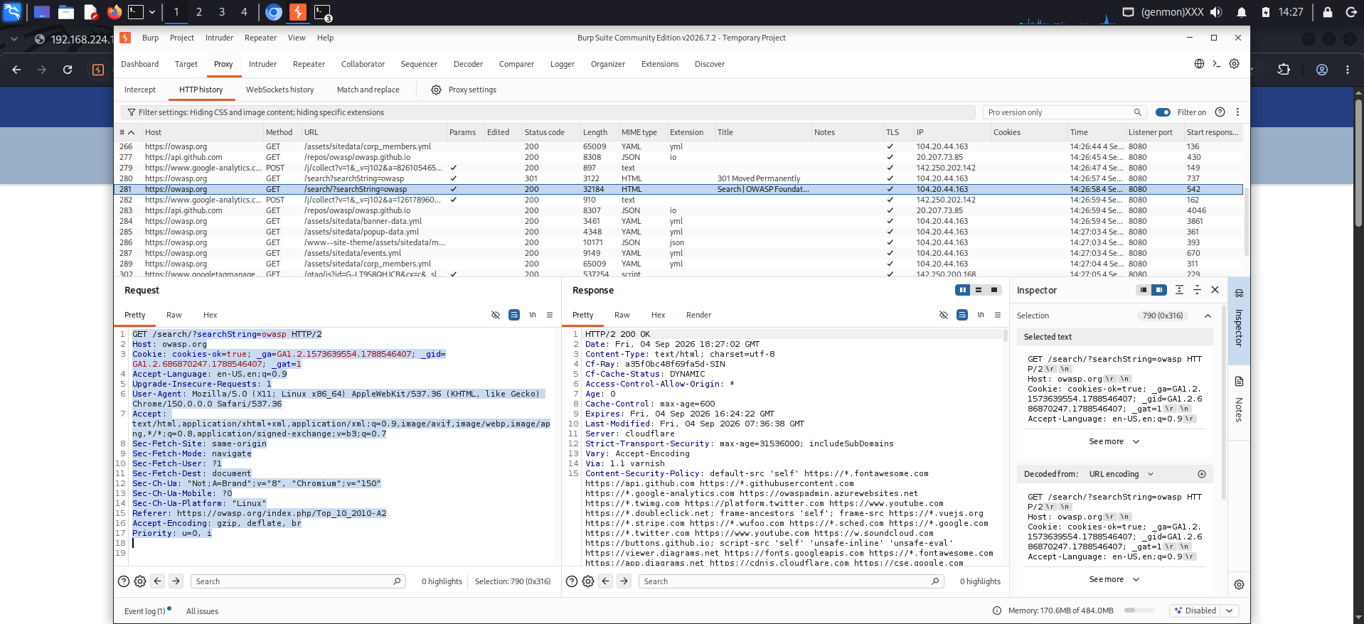
ESTABLISHING BASELINE:
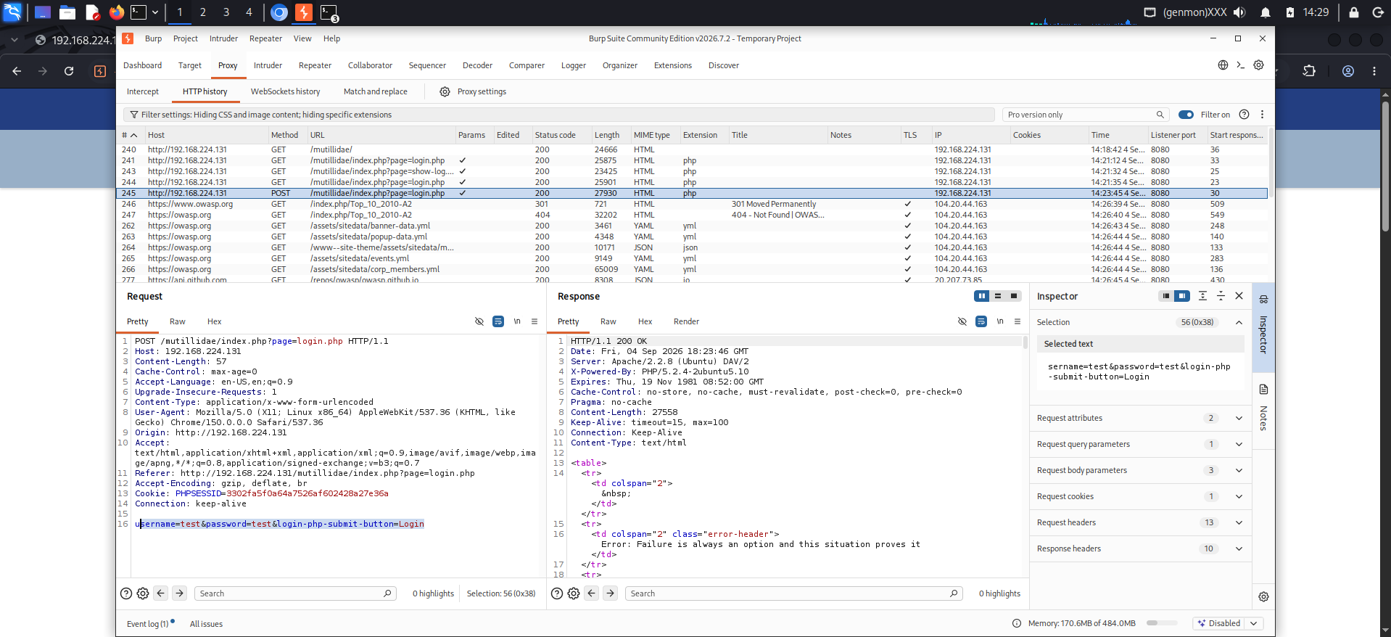
CONCLUSION:
Mutillidae was successfully accessed and its login page was identified as an input point. Burp Suite was used to observe the POST request and identify user-controlled parameters such as username and password. A normal input value was submitted to establish baseline behaviour before performing any further authorized security testing. This provides a clear reference point for comparing responses during the next testing steps.
PART10-Manual SQL Injection Concepts:
Single quote test:
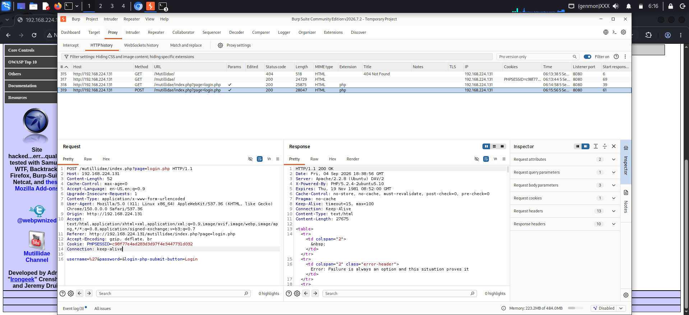
TRUE CONDITION:
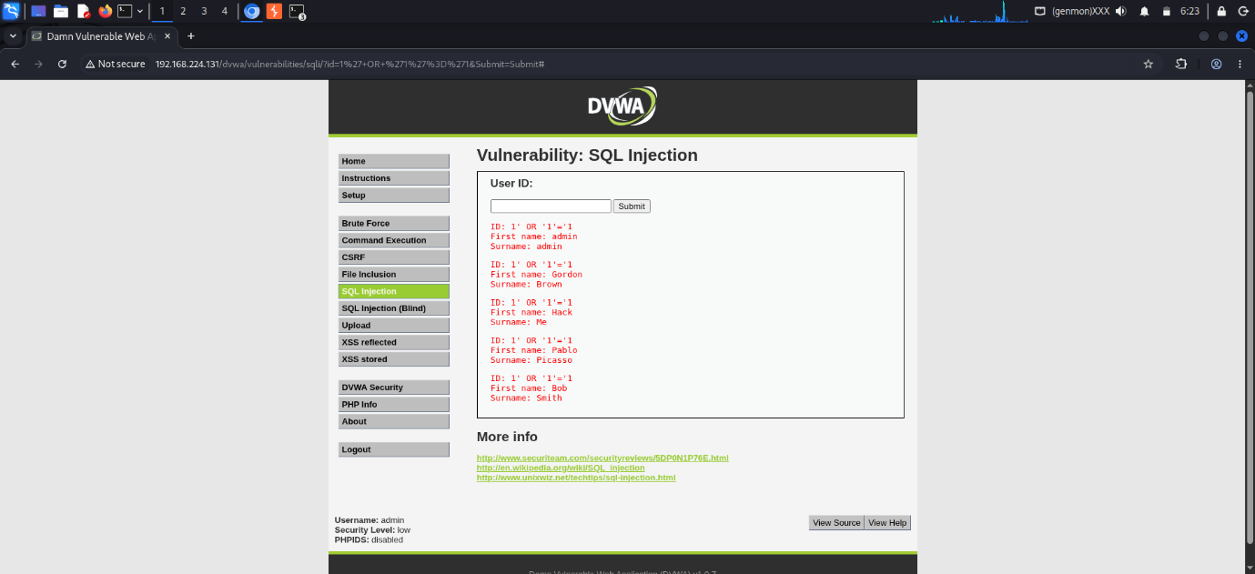
FALSE CONDITION:
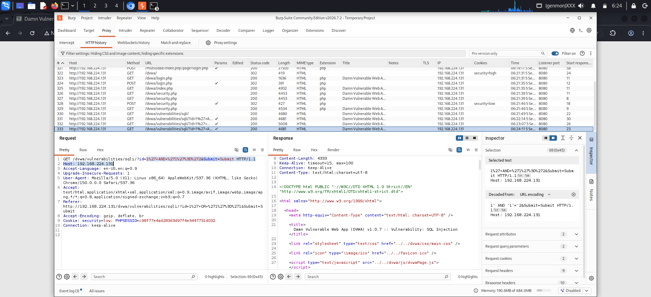
DIFFERENCE:
TRUE CONDITION: 1' OR '1'='1
The TRUE condition returned multiple records from the database. The application displayed several user records, including admin, Gordon Brown, Hack Me, Pablo Picasso, and Bob Smith.
False condition: 1' AND '1'='2
The FALSE condition did not return the same user records. No matching records were displayed.
Inspecting in Burp:
TRUE CONDITION PARAMETER:
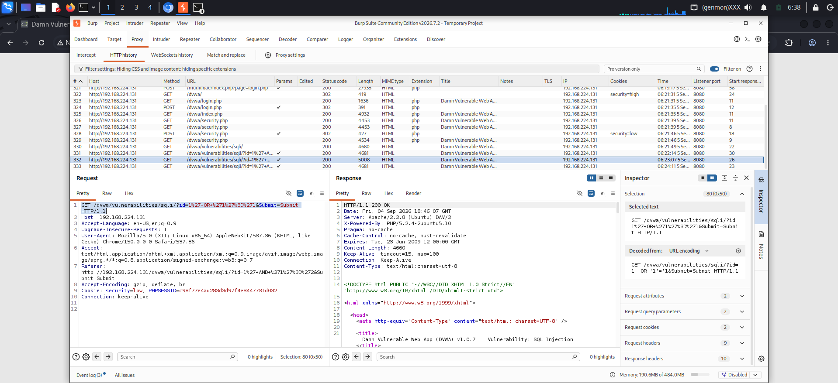
FALSE CONDITION:
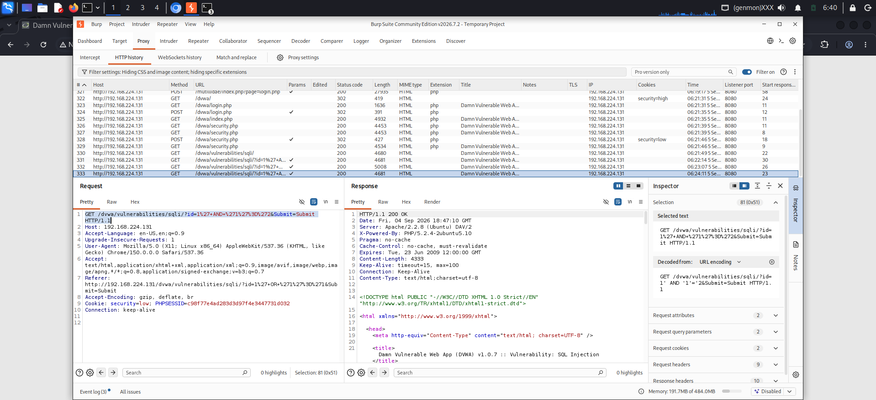
CONCLUSION:
The TRUE and FALSE conditions produced different results. The TRUE condition caused the application to return multiple database records, whereas the FALSE condition did not return those records. This difference demonstrates that the supplied User ID input influenced the SQL query's conditional behaviour in the intentionally vulnerable DVWA environment.
SQLMap Guided Verification:
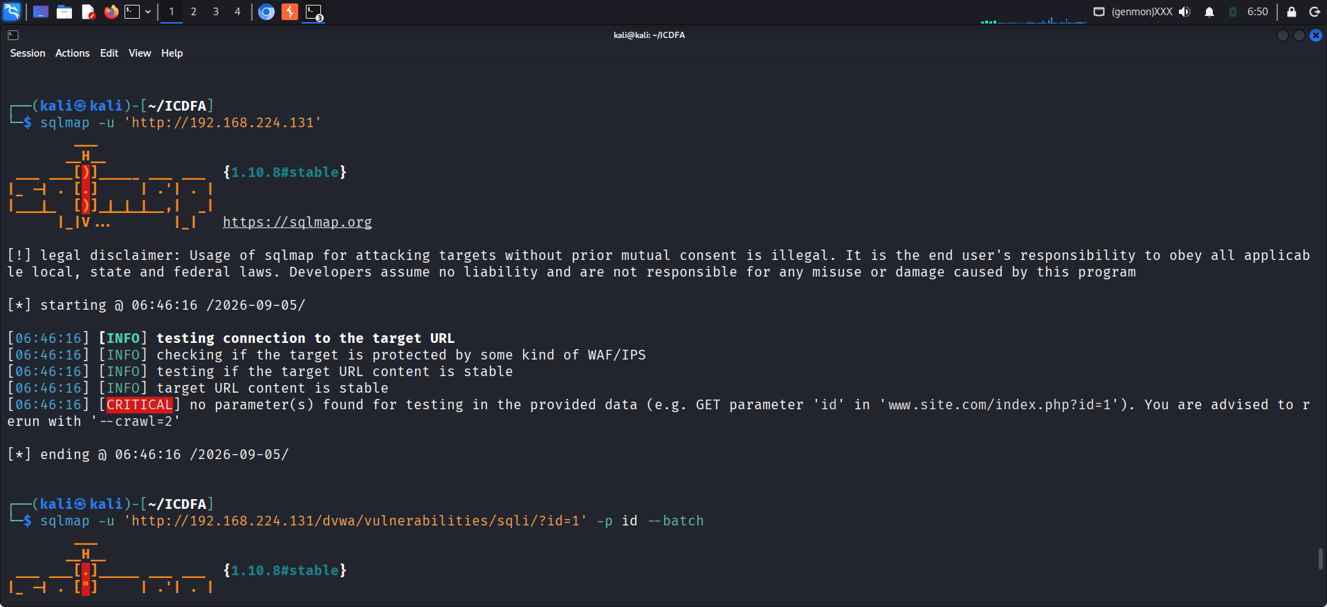
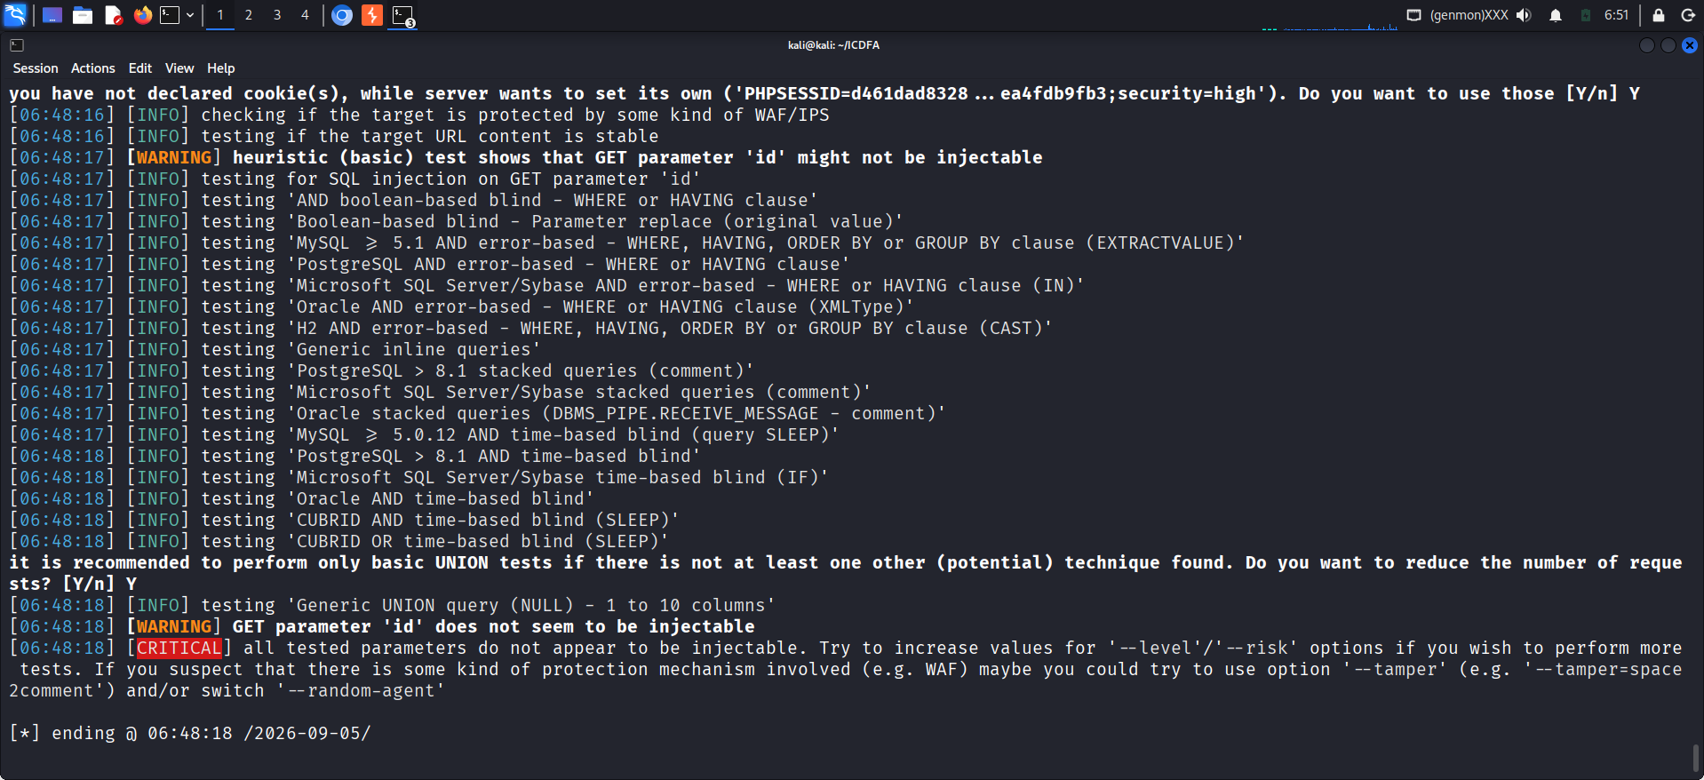
Explanation:
SQLMap successfully parsed the target URL but found no parameter to test.the id parameter was tested, but SQLMap reported it as not injectable and redirected to the DVWA login page.
DATABASES:
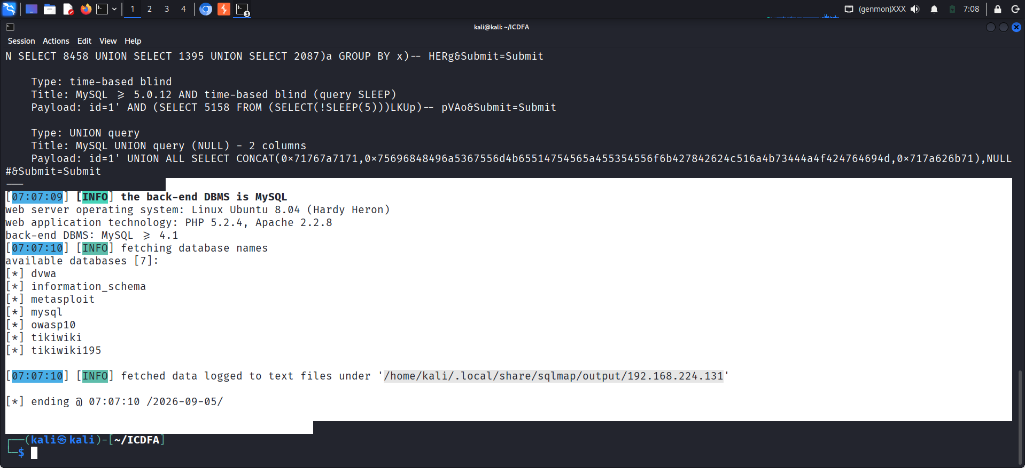
LIST OF TABLES:
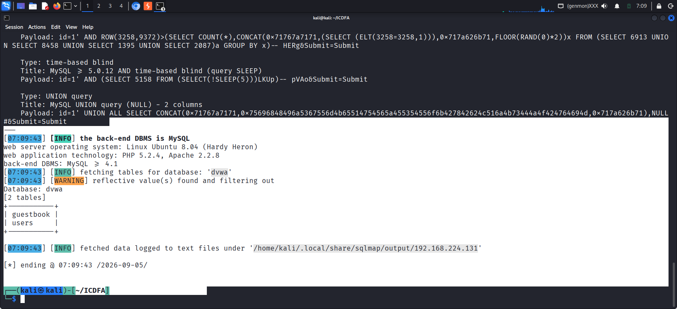
Conclusion:
By supplying an active session cookie via a raw HTTP request file, the 302 redirection barrier was successfully bypassed to reach the authenticated DVWA endpoint. SQLMap confirmed multiple SQL injection vectors—including Boolean-based, error-based, time-based, and UNION queries—on the id parameter against the MySQL backend. Subsequent enumeration mapped seven distinct databases, including dvwa and information_schema. Ultimately, this exercise underscores the critical need for parameterized queries and robust input validation to prevent full backend data exposure.
DEFENSIVE RECOMENDATIONS:
To secure web applications against file upload and SQL injection vulnerabilities, implement the following defensive controls based on the lab findings:
File Upload Security Controls
Strict Validation: Replace client-side trust of extensions and MIME types with robust, server-side allowlists for permitted file types and deep content validation.
Storage Isolation: Store uploaded files outside of the web root, or explicitly disable script execution privileges within the upload directory.
Filename Sanitization: Prevent path traversal and malicious overwrites by generating randomized, server-side filenames alongside strict file size limits and malware scanning.
Database Security Controls
Parameterization: Eliminate string concatenation of user input by implementing parameterized queries and prepared statements across all database interactions.
Error Handling: Suppress verbose database error messages shown to users; instead, return generic error pages while securely logging detailed debugging info internally.
Privilege Management: Enforce the principle of least privilege by ensuring database accounts used by the application possess only the minimum necessary permissions.

